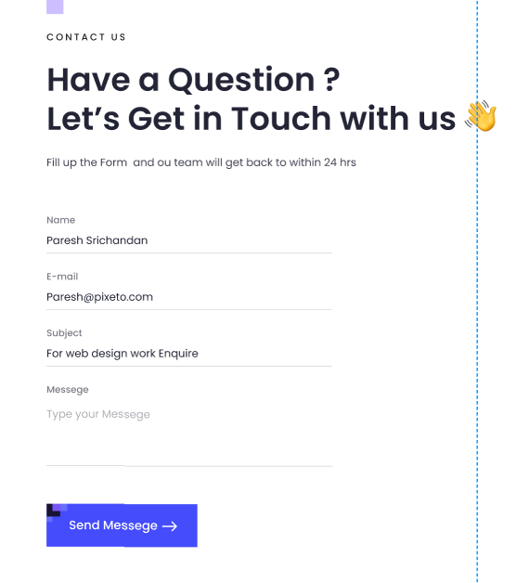

Contact us:poppins medium 14, renk kodu: 000000

2.satır: poppins semibold 48, renk: 232536

3. Satır: poppins regular 16, renk: 232536

FORM

TİTLE:Poppins medium 14 renk: 232536

Placeholder: Poppins medium 16 renk: 232536

Line renk kodu: 232536

Send butonu: poppins medium 18,renk: FFFFFF

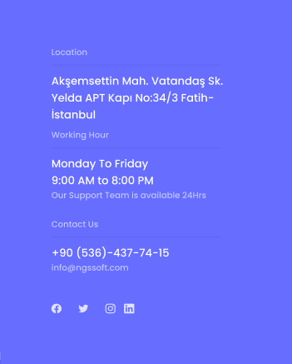

Location: poppins medium 14 renk: FFFFFF

Akşemsettin mah.: poppins medium 14 renk: FFFFFF

Çizgi: renk 000000 %8